Coordinators Training Manual for Regularly Scheduled Series (RSS)

Office Number: 801-507-8470
Toll Free: 1(800) 910-7262
Email: ipce@imail.org
www.intermountain.cloud-cme.com

Table of Contents
Table of Contents 2
RSS Dashboard Introduction 3
RSS Dashboard Columns 4
RSS Icons and Status Definitions 8
Using the RSS Dashboard 11
Claim Credit Code 12
RSS Calendar 12
RSS Activity Editor 13
RSS Flyer 14
SMS Texting 15
RSS Flow Chart 17
RSS Roles and Responsibilities 18
Ongoing Tasks 18
Annual Tasks 21
Honoraria Interprofessional Continuing Education (IPCE) Policy 22
72-Hour Conflict of Interest (COI) IPCE Policy 25

RSS Dashboard Introduction
CloudCME® offers the RSS Dashboard to users who want to easily manage RSS child activities. In the RSS Dashboard, users can view the child status, activity details, presentations and COI status, target audience, comments, and approval status. Users can also edit the activity, manage, and email Planners, Faculty, and Owners/Coordinators, upload and download presentations, override approval and generate flyers.
First, log into CloudCME® by clicking Intermountain Healthcare Caregivers (if you have an Intermountain single sign-on account) and entering your Intermountain username and password. Otherwise you’ll sign-in by selecting Non-Intermountain Healthcare Caregivers and entering your email and password.

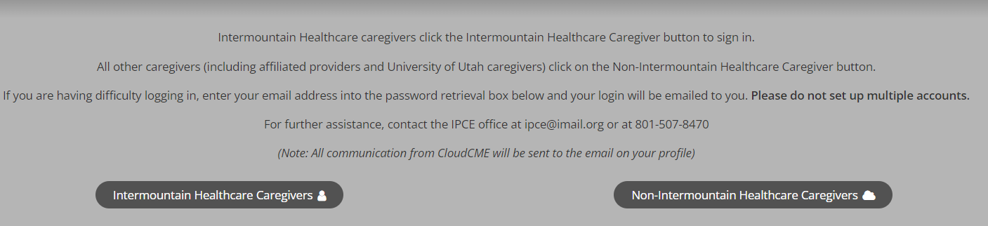

Note: If you notice any of your planners or speakers have two or more profiles please contact IPCE to merge their profiles.

At the bottom of the screen, next to the drop-down box, click the Administration link.

Then, from the main menu, go to Activities > RSS Dashboard.

NOTE: This screen may vary depending on the user screen access that has been given.
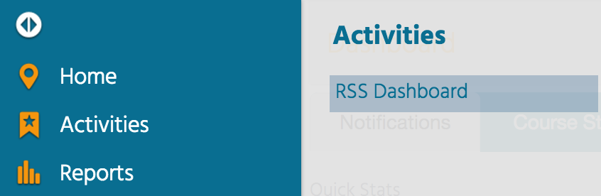

The RSS Dashboard screen will display.
Search for an RSS child activity by typing the activity name in the search box and/or filtering by Date Range, Status, Owner, Administrator, Location, Department, Planner, Faculty or Specialty. Click the Search button to display results.
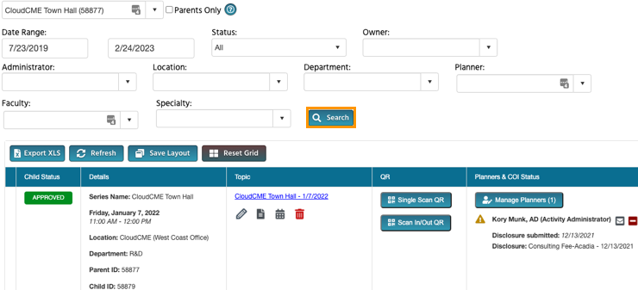

RSS Dashboard Columns
The data table contains several columns to assist the Coordinator in managing the RSS activity planning process.
NOTE: Peer Review no longer triggers child event status changes. Status changes are now driven by the COI Mitigation Manager screen.
The following columns are included in the RSS Dashboard:
- Child Status - As the RSS child activity goes through the approval process, this column will continuously update the status to Incomplete, Pending, Approved, Rejected or In Review.
  - In Review - This status displays if faculty have been added with a completed disclosure and at least one financial relationship has been declared, triggering a COI Mitigation process needed. If one faculty member is rejected, and other faculty have been approved, the Child Status will remain In Review.
NOTE: A Review Disclosures indicator will display in the Status column if a user has submitted a new disclosure prior to the activity starting. There may be a new potential COl relationship that needs to be reviewed. Once the COI status has been addressed, the RSS status icon will update to the proper status and the indicator will be cleared.

- Details - This column will display the Series Name, the date and time of the child activity, Location, Department and Parent ID and Child ID.

Note: The claim credit code will always be the Child ID for each session
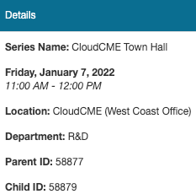
3. Topic - This column displays the name of the RSS child activity as well as the option to edit or create a flyer, view recurrence settings, and delete the activity.
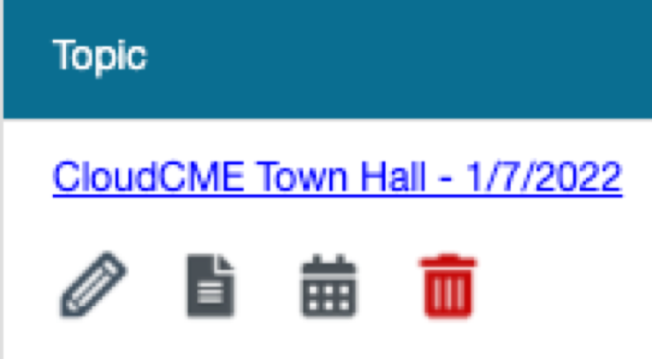

4. QR - Single Scan QR is used for recording attendance by users logged in to the CloudCME® mobile app. (Note: Do not use QR codes for recording attendance for an RSS session, this function is only used for conferences and courses)
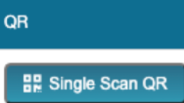

5. Faculty - This column displays Faculty assigned to the RSS child activity. The disclosure status will display beneath each faculty name along with their disclosure submission date. If more than 3 faculty members are assigned to the child activity, there will be a "View All" link that when clicked, will expand to show all assigned Faculty, or roll up the listing view.
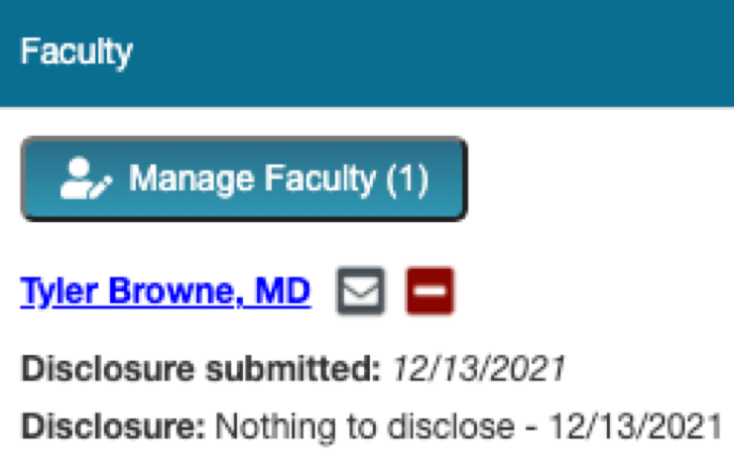
Clicking the Manage Faculty button will display a pop-up screen that allows RSS Coordinators to email, view, add or remove Faculty, request disclosures and file uploads, and export faculty member information.
- To add a faculty member to the activity, type and select the member’s name in the drop-down box. Click the Add Faculty button. The new faculty member will be added to the activity and the member’s information will display in the Manage Faculty table.
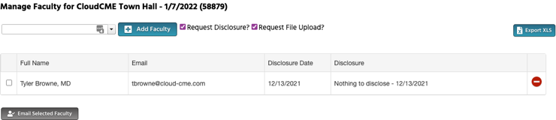
- Click the faculty member’s name to request disclosures, presentation files and other optional information, edit a member’s profile, and view uploaded files and past courses.
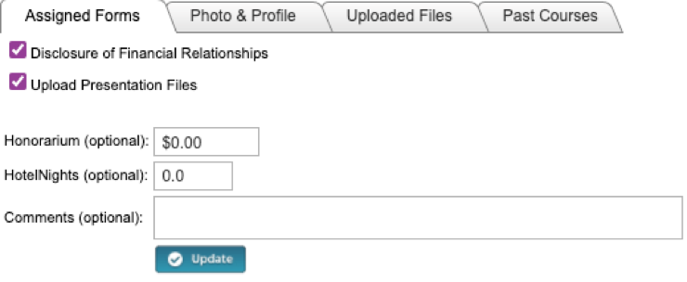

6. Presentation & COI Status - This column displays a faculty members' status, COI status, as well as icons to Upload, Download and Remove a faculty presentation. To upload a presentation, click the Upload icon, complete the Attestation, and select the file that will be uploaded. Once a file has been uploaded, the download and delete icons will display.
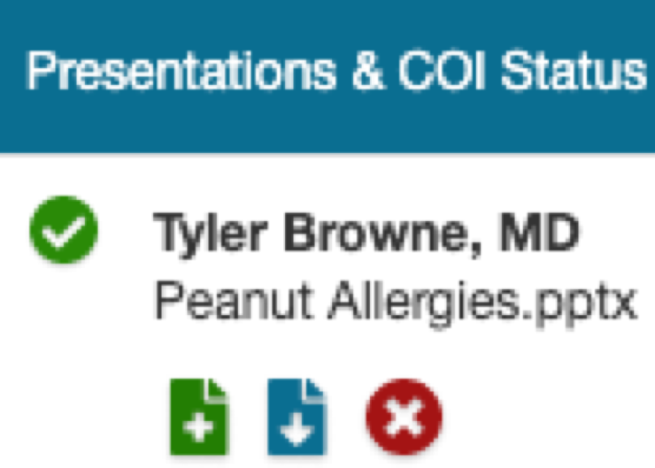

7. Target Audience - This column displays the Specialties and Professions that were selected during the parent activity setup. These can be revised on the RSS Activity Editor when the Pencil icon is selected.

8. Owners/Coordinators - This column displays the child activity Owners' and/or Coordinators' names as well as the option to send emails.
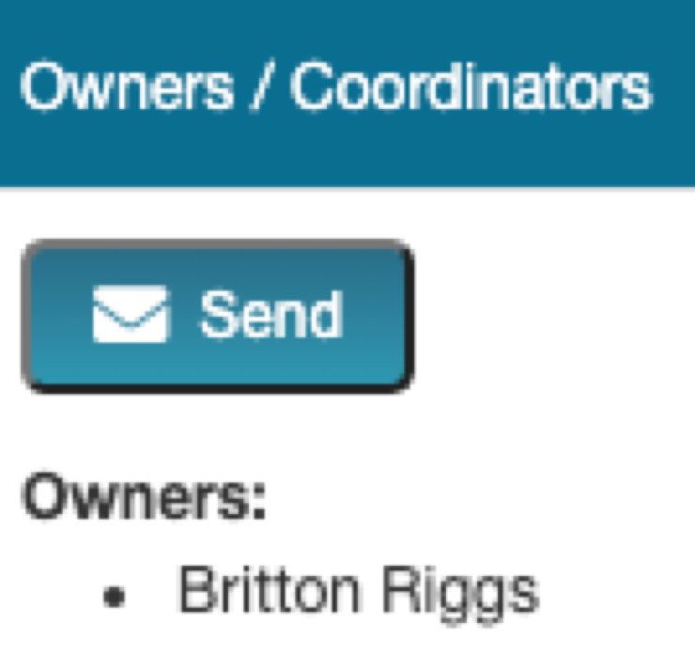

RSS Icons and Status Definitions

The columns in the RSS Dashboard contain several icons:

The following icons (1-4) can be found in the Topic column:
1. Pencil - This icon opens the RSS Activity Editor. Here, a user can edit the child activity information.

2. RSS Flyer - The system will generate an RSS flyer for distribution. Faculty must be assigned to the activity before a flyer can be generated. The flyer template can also be customized for a unique RSS child or parent activity. The template can be applied to all child activities of the parent.
- To associate the revised flyer to the RSS parent for use per each child activity of the parent, click the Upload Flyer button, select the revised flyer from your desktop, and check the Use flyer/template for Parent? checkbox.
NOTE: The RSS flyer will be saved in the Documents tab in Activity Manager for the RSS activity.

3. Calendar - Click this icon to view and edit scheduled RSS child activities.
4. Trash - Click this icon to deactivate/delete an RSS child activity. A pop-up window will display to confirmation deletion.

The following icons (1-8) can be found in the Presentations & COI Status column:
1. Incomplete - This status represents Faculty where there is no disclosure on file, or their disclosure on file has expired. RSS Coordinators/Owners will see Incomplete by default until Faculty are assigned and disclosures have been completed.

2. Pending - This status represents Faculty whose disclosure and presentation are currently undergoing the COI Mitigation process. The system will send an email to the Administrator and Owner, containing all RSS child activities in which the activity status has been changed to Pending.

3. Disclosure Updated - This icon will display if a user has submitted a new disclosure prior to the activity starting. There may be a new COI that needs to be reviewed. Once the COI status has been addressed, this icon will update.

4. Approved - This represents Faculty who have completed a disclosure, no financial relationships have been declared or, if identified, COI mitigation has been satisfactorily completed. The Approved status will also display if an Administrator or Activity Administrator conducts an Approval Override or if in Administration > Preferences > COI Resolution the "Automatically Approve COI When Users Have Nothing to Disclose" checkbox is checked.

5. Rejected - This represents Faculty who have completed a disclosure, at least one financial relationship has been declared, and the conflict is deemed immitigable. The child activity status is then updated to Rejected. The Coordinator will remove this faculty member, select a new faculty member, and begin the process again.

6. Upload - Upload a presentation file for the faculty member. Once a presentation has been uploaded, the download and delete icons will display.

7. Download - Download a faculty member's presentation file.

8. Delete - Delete a faculty member's presentation file.

The following icons (1,2) can be found in the Faculty column:
1.Email: Draft and send an email to the selected Faculty Member/Planner.

2.Remove: Remove a Faculty Member/Planner from the RSS child activity.

The following button can be found in the Owners/Coordinators column:
1. Draft and send an email to Owners/Coordinators.

Using the RSS Dashboard
The RSS Dashboard provides a minimized view to easily manage RSS activities. Coordinators will see all activities that they have been assigned as Coordinator/Owner except those that are Approved (unless “Approved” is selected in the Status search).
There are a variety of ways to search the RSS Dashboard. Users can search by the activity name, Date Range, Status, Owner, Administrator, Location, Department, Planner, Faculty or Specialty. Click Search to display results in the Dashboard.
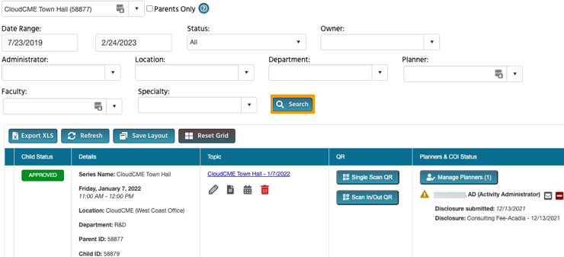

NOTE: Please see the section titled RSS Icons and Status Definitions provided above for a definition of each status.

Claim Credit Code

Each RSS session will be associated with a specific Claim Credit Code which is the Child ID found under the Details column. Do not use the Parent ID as the claim credit code.

RSS coordinators will need to provide this code at the end of each RSS session and participants will have 24 hours to claim their attendance for the session. Credit is only awarded for the live session; participants cannot claim credit for a recorded session unless you’ve sought prior approval from the IPCE department. Recordings should not be published/posted within 24-hours of the live RSS.

RSS Calendar

Click the calendar icon in the Topic column. A pop-up window will display, showing a calendar with the reoccurrence dates of the child activities. To change the date of a child activity, users can drag and drop the child activity to a new day.

To edit a child activity, double-click on the activity in the calendar. A pop-up window will display. The radio button will default to Edit only this occurrence (Do not select Edit the Series). Click OK.
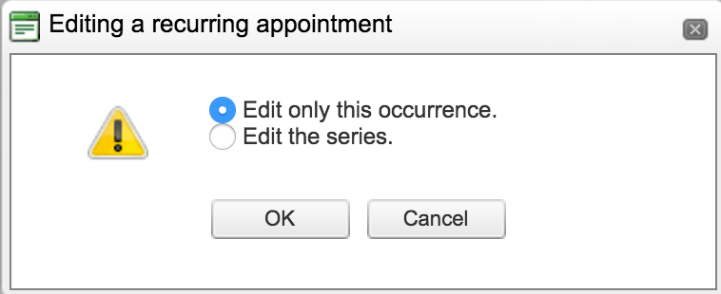
To edit the title of the child activity, type the new title into the textbox that will display. To revise the date or time the activity will occur, click the Options button.
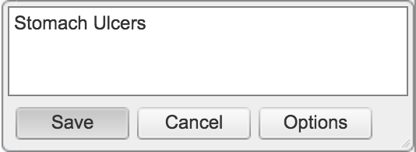
A new window will display. Here, users can create a child activity by filling in the text box, selecting the date and time the child activity will occur, and whether the activity has a recurrence.

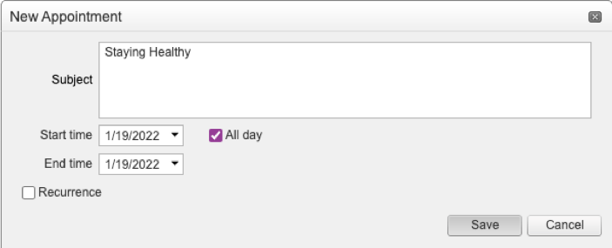

RSS Activity Editor

Click the Pencil icon from the RSS Dashboard activity with the updated title. This icon can be found in the Topic column. The RSS Activity Editor screen will display. Here, users can edit and/or add additional information and upload supporting documentation for the child activity.

NOTE: The child activity title will display on users’ transcripts.

When all information has been entered, click the Save & Close button.

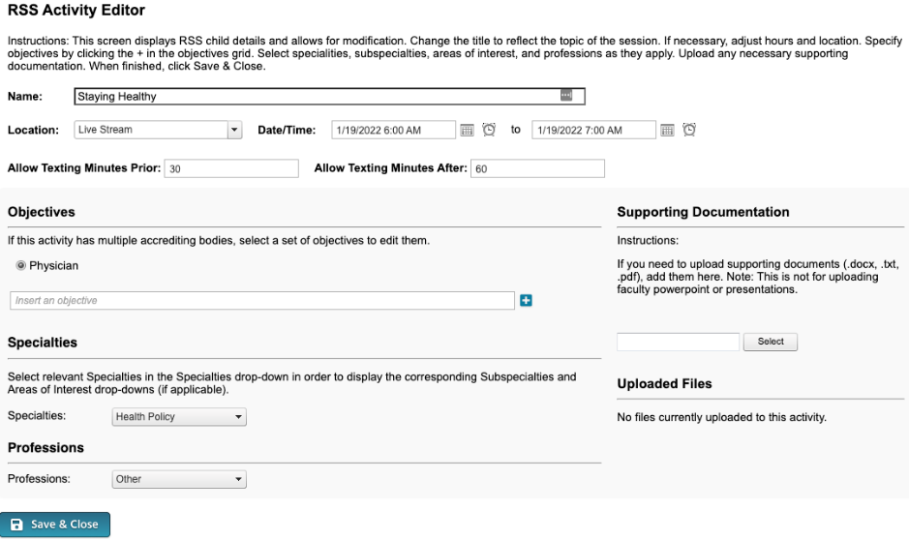

RSS Flyer
To access the RSS flyer, click the RSS Flyer icon and then click Download Microsoft Word Version*. The flyer will open as a Word document.
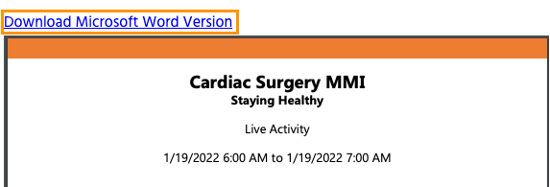

To associate a self-generated flyer* with a unique RSS child activity, click the Upload Flyer button, select the revised flyer from your desktop, and click the Save button.
Note: The flyer must be a word document
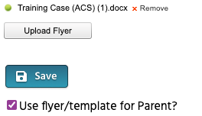
*Please note all flyers must be proofed and approved by the IPCE office and contain all required accreditation elements. If you are using the CloudCME generated flyer, please wait to download the flyer until after the session has been approved. This will ensure that this has gone through the IPCE proofing process.

SMS Texting

These instructions are intended only for users that have an active account in CloudCME®. Attendance can only be recorded within 24 hours of the conclusion of the RSS session.
Step 1: First, users must pair their mobile phone to their account in CloudCME®. Text the email address associated with this account to (844) 989-1332. A message will be sent that looks like the one below, confirming that the phone number has been updated.
NOTE: This is a one-time operation.

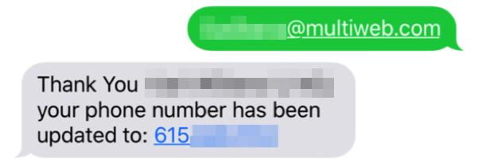

Step 2: To record attendance to an activity, text the activity ID or code that has been provided for the activity. A message will be sent that verifies that activity attendance has been recorded.
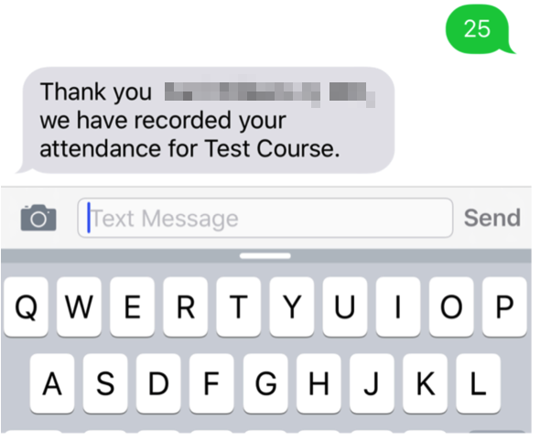

NOTE: Attendance can only be recorded once to an activity. If a user tries to record attendance an additional time, they will receive the following message:

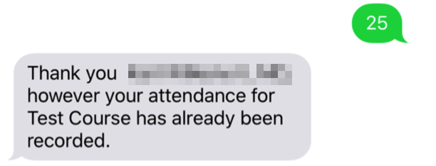

If a user attempts to use an activity code that does not exist, they will receive the following message:
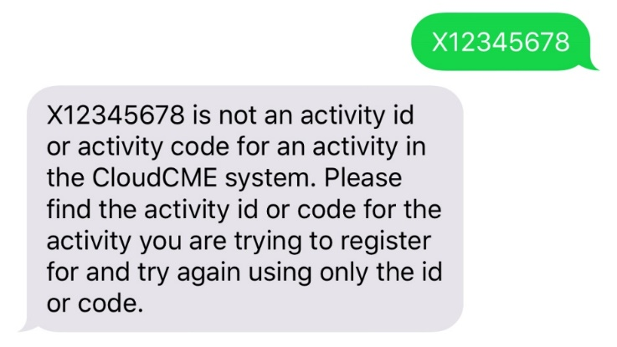

RSS Flow Chart

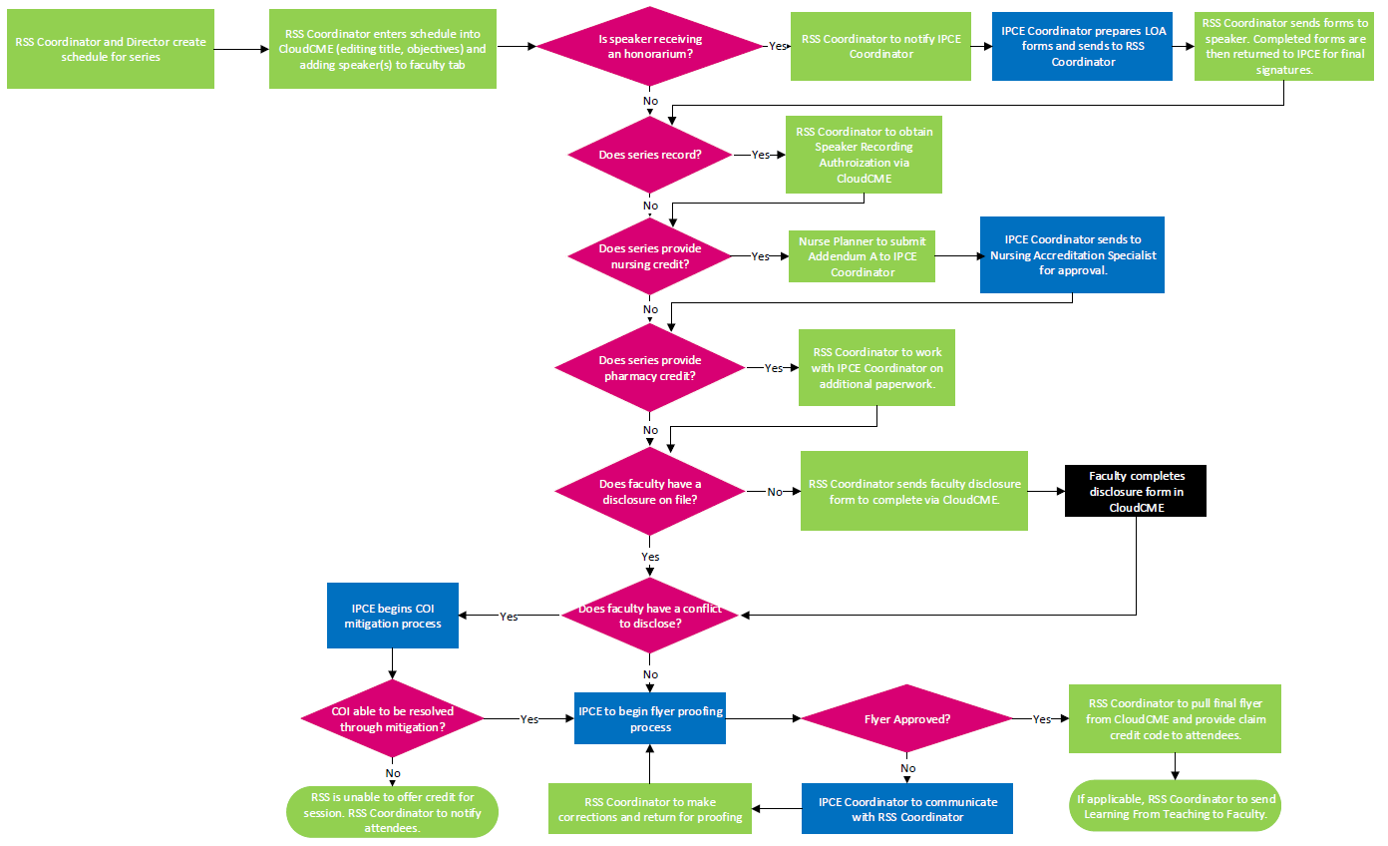

RSS Roles and Responsibilities

Ongoing Tasks

The frequency of these tasks will vary based on the frequency of your series.

- RSS Coordinator and Director should establish the calendar and speakers. It is best practice that this is done 2 months in advance. IPCE’s minimum expectation is that this is done 1 month in advance.
- RSS Coordinator will update the session title (if applicable) in CloudCME and add objectives.
- RSS Coordinator will enter the speakers into the faculty tab in CloudCME.
- RSS Coordinator will verify that the RSS dashboard matches internal department calendars (i.e. the session dates/times are updated if you have made changes from your regular frequency).
  - RSS Coordinator is responsible for adding/deleting dates of children.
  - RSS Coordinator to notify IPCE Coordinator if a speaker needs to be added that does not have a CloudCME profile.
- RSS Coordinator will add IPCE Coordinator, IPCE Manager, and IPCE Director to the distribution list for the series. The IPCE Nursing Accreditation Specialist should be added to the distribution list for series with nursing credit.
- RSS Coordinator will immediately notify the IPCE Coordinator if any changes are made to the Planning Committee Members and/or faculty changes.
- IPCE Coordinator will ensure that appropriate paperwork is assigned to the children in CloudCME if the children have to be revised.
- RSS Coordinator will follow up with faculty who do not have a current disclosure on file. This includes disclosures for those on the Planning Committee. All disclosures should be completed at least 2 weeks in advance but at a minimum of 1 week in advance.
- IPCE Coordinator will follow up with RSS Coordinator about missing paperwork (i.e. recording authorization). IPCE Coordinator will send the missing paperwork email via CloudCME to faculty.
- For series with nursing credit, IPCE Coordinator to follow up with Nurse Planner to collect Addendum A for each session. This should be received 1-2 weeks prior to the event. IPCE Coordinator to send to Nursing Accreditation Specialist for approval.
- If series provides pharmacy credit, RSS Coordinator will work with IPCE Coordinator and Pharmacy Teaching and Scholarship Manager to ensure additional paperwork is received.

- RSS Flyers
  - CloudCME Generated –
    - IPCE Coordinator will pull the flyer when the faculty have been added. This is done at least one week before RSS.
      - If a COI needs to be resolved, the IPCE Coordinator will notify the IPCE Nursing Accreditation Specialist. IPCE Nursing Accreditation Specialist cannot start the resolution process without the speaker’s session title.
    - IPCE Coordinator will verify that the MOC Part II statement is included on the flyer for series that provide MOC Part II credit.
    - IPCE Coordinator will upload the final approved flyer in CloudCME which will send an automated email message to the RSS Coordinator.
    - RSS Coordinator is responsible for pulling the approved flyer and providing the claim credit code (known as the child code in CloudCME) to attendees.

    - RSS Coordinator is responsible for informing the IPCE Coordinator if any changes occur after the series is approved.
  - Non-CloudCME Generated –
    - RSS Coordinator will upload the flyer to CloudCME and email their IPCE Coordinator that the flyer is ready for review.
    - IPCE Coordinator will follow the IPCE proofing process and upload the final flyer to CloudCME.
    - RSS Coordinator is responsible for pulling the approved flyer and providing the claim credit code (known as the child code in CloudCME) to attendees.
    - RSS Coordinator is responsible for informing the IPCE Coordinator if any changes occur after the series is approved.
- RSS Coordinator should use the claim for credit slide provided by the IPCE Coordinator with instructions on how to claim credit. The RSS Coordinator will need to update the credit code on the slide for each session.
- IPCE Coordinator will attend 1 meeting per series each year and complete a Live Observation form.
- Honorariums
  - While it is not common for most RSS’s to provide an honorarium to speakers, if it is decided to pay an honorarium then the RSS Course Director and Coordinator must conform to the IPCE Honoraria Policy (see policy below) and an LOA must be signed by the speaker before the event. Honorariums and RSS expenses are always charged to the hosting department’s budget. These should never be charged to IPCE.
  - The RSS Coordinator will notify the IPCE Coordinator of the honorarium payment.
  - IPCE Coordinator will put together the appropriate paperwork (LOA and W9 – if applicable) to send to the RSS Coordinator. The RSS Coordinator is responsible for sending this to the speaker receiving the honorarium. This must be done prior to the event or honorarium is forfeited.
    - RSS Coordinator sends completed paperwork to IPCE Coordinator
    - IPCE Coordinator sends to IPCE Director for signature
    - IPCE Director will sign and return to IPCE Coordinator. The IPCE Coordinator will return the fully executed LOA to RSS Coordinator.
  - RSS Coordinator will process the honorarium payment and follow up to ensure it’s been completed.

Annual Tasks

August –
- IPCE Business Analyst creates Annual Survey using Qualtrics and distributes survey links to IPCE Coordinator
- IPCE Coordinator sends RSS Coordinator unique link for their RSS Survey along with email template.
September –
- RSS Coordinator disseminates Annual Survey to their attendees using email template provided by IPCE. The Annual Survey is open from 10/1 – 10/15.
October –
- RSS Course Director and Coordinator continue to promote completion of Annual Survey to series attendees before the survey closes on 10/15.
- IPCE Business Analyst provides results of Annual Survey to RSS Course Director and Course Coordinator by 10/22
November –
- RSS Course Director and Coordinator complete Annual Review using data from the Annual Survey.
- If the series has nursing credit, the Nurse Planner will complete Addendum D and Summative Evaluation and return to IPCE Coordinator.
- RSS Course Director and Course Coordinator (and Nurse Planner if applicable) will need to renew their application in CloudCME to continue providing credit for their series.
December –
- IPCE Director and Nursing Accreditation Specialist review applications.
- Once the application is approved, IPCE Coordinator creates children for approved activities.
- RSS Course Director and Coordinator should meet to establish a calendar and speakers for the year.
- IPCE Nursing Accreditation Specialist will reach out to Nurse Planner regarding required paperwork needed for each session. IPCE Coordinator to follow up with Nurse Planner and send to IPCE Nursing Accreditation Specialist for approval.

Honoraria Interprofessional Continuing Education (IPCE) Policy

Policy Statement
The purpose of this policy is to define the criteria and requirements associated with honoraria for presenters at Intermountain Healthcare-approved accredited educational activities. This policy applies to educational activities accredited by the Intermountain Interprofessional Continuing Education (IPCE) department.
Scope
Intermountain Healthcare, Inc.
Definitions:

Interprofessional Continuing Education (IPCE) - A specific form of continuing education that helps those in the health care field maintain competence and learn about new and developing areas of their field. These activities may take place as live events, written publications, online programs, audio, video, or other electronic media.
Honorarium – A payment or form of remuneration given for professional services.
Letter of Agreement (LOA) – A contract the faculty member completes that includes the presenter’s responsibilities including elements to address accreditation requirements and other compliance information as required by Intermountain.
Provisions
- Course director(s) and/or planning committee may offer an honorarium to a presenter for his/her contribution to an educational activity. Honoraria will be consistent with fair market value standards.
- Presenters, who are employed by Intermountain Healthcare (Intermountain), can only accept an honorarium when doing so is in accordance with the employee’s contract (if applicable), Intermountain HR policies, and Intermountain’s Conflict of Interest Policy.
  - Intermountain-employed physicians whose job description includes participation in educational activities are not eligible to receive an honorarium.
  - Intermountain-employed non-physician clinicians are generally not eligible for honoraria.
  - Non-Intermountain-employed non-physician clinicians may be eligible to receive an honorarium.
  - Non-Intermountain-employed physician presenters are responsible for ensuring compliance with his/her own employment contract and his/her employer’s rules and regulations.
  - Non-Intermountain-employed physician presenters who have a financial relationship with Intermountain, or who practice within the Intermountain Service area will require verification of eligibility to receive an honorarium by IPCE and the Physician Contracting Department.
  - Course directors and/or planning committees will determine the amount of honorarium for presenters based on such factors as:
    - Speaker background and experience
    - Typical range of honoraria for the profession and specialty
    - Length and complexity of the instruction to be provided
    - Other relevant factors.
- Honorarium limits:
  - Physicians who are from the Intermountain Healthcare service area: $250 per presentation.
  - Physicians who are from outside the Intermountain service area: $1500 per activity.
  - A proposed honorarium greater than these limits requires advance approval by both co-Chairs of the IPCE Education Review Committee and the AVP of Physician/APC Affairs prior to any communication about honorarium amounts to speakers or potential speakers.
  - The honorarium limit for eligible non-physicians should be consistent with the presenter’s salary and the time spent with presentation at the educational activity.
  - Honoraria will be subject to review and approval by the IPCE Director and IPCE Medical Directors.
- Course director(s) will include the proposed honorarium payment in the content of the application.
  - The IPCE program staff will contact the presenter to obtain the necessary documentation prior to the educational activity.
  - The IPCE program staff will request the necessary payroll information from presenters (e.g., completed IRS W9 form, Social Security number, Taxpayer Identification Number), unless the information is already on file.
- Upon completion of the educational activity, the IPCE program staff will complete and submit to the Intermountain Healthcare Accounts Payable department all the financial support documentation that is necessary for distribution of honorarium payments.
  - For Intermountain employees receiving an honorarium:
5.11 Honorarium payments will be processed during the second pay period following the educational activity and will be considered income and subject to applicable state and federal taxes.
5.1.2 Payments will be distributed with regular pay on the standard bi-weekly Intermountain pay cycle.
  - For non-Intermountain employees receiving an honorarium payment:
    - Honorarium payments will be processed and mailed within 30 days of the educational activity and completion of appropriate documentation.
    - Payment is made based on paperwork, all applicable taxes apply.
- Honoraria will be processed by Intermountain IPCE department from Intermountain Healthcare, Inc. and attributed to the specific conference project.
- Faculty will forfeit honoraria unless all required paperwork (e.g., disclosure, LOA, presentation materials, biographic data form, W9, etc.) is completed and submitted at least five business days prior to the event.
- Course directors may choose to provide a token of appreciation to presenters.
  - The token for each presenter will be $50 or less in value. Tokens worth more than $50 need to be approved by both co-chairs of the IPCE Director prior to any communication about the token to speakers or potential speakers.
  - If the token is in the form of a cash equivalent or a tangible good greater than $50 in value to each presenter, it will be reported to Intermountain Payroll as taxable income from Intermountain Healthcare.
  - If a token of appreciation will be given, it will be noted in the educational activity application and activity budget and approved through the standard application process.
  - The Intermountain IPCE staff will include the provision of a token of appreciation in the speaker’s letter of agreement.
Applies to Alta View, American Fork, Bear River, Cassia, Cedar City, Delta, Fillmore, Garfield, Heber, IMED, Layton, LDS, Logan, McKay, Orem, Park City, Primary Children’s Hospital, Riverton, Sanpete, Sevier, Spanish Fork, St.
George, TOSH, Utah Valley
Unpublished work. © Intermountain Healthcare. All rights reserved. This document contains Intermountain Healthcare’s confidential or proprietary information and may not be shared outside of Intermountain except as specifically authorized by Compliance and the Intellectual Property Office.
Disclaimer: If services are not provided at a specific location, the document content does not apply.

72-Hour Conflict of Interest (COI) IPCE Policy

Policy Statement
The purpose of this policy is to ensure all conflict of interest forms are received a minimum of 72-hours prior to an educational event (e.g. regularly scheduled series, conferences, courses, etc.) to eliminate the potential for real or perceived bias from commercial influence at all educational activities accredited by the Intermountain Interprofessional Continuing Education (IPCE) department.

Scope
Intermountain Healthcare, Inc.

Definitions:

ACCME - Accreditation Council for Continuing Medical Education

ACPE - Accreditation Council for Pharmacy Education

ANCC - American Nurses Credentialing Center

CE - Continuing Education

CloudCME® - A platform for managing all aspects of a continuing education (CE) department.

Intermountain Interprofessional Continuing Education (IPCE Department - IPCE has the responsibility and authority to provide accredited education for advanced practice clinicians, nurses, pharmacists, pharmacy technicians, and physicians.

Relevant Financial Relationship(s) - Financial relationships in any amount, which occurred in the twenty-four month period preceding the time that an individual was asked to assume a role controlling content of the CE activity and which relate to the content of the educational activity, causing a conflict of interest.

RSS - Regularly scheduled series

Standards for Integrity and Independence in Accredited Continuing Education - Independence from commercial influence is the cornerstone of accredited continuing education. These standards were created by the ACCME to reflect the values of the continuing education community to assure the delivery of high-quality learning experiences and sustain the protection from commercial bias and marketing. These standards apply to all accredited educational activities including ACCME, ACPE, and ANCC activities.

Provisions
- Course directors planning committee members, faculty, and all individuals with control of content will be required to complete the disclosure of financial relationships form in CloudCME® when they are assigned to an educational activity accredited by IPCE (e.g., RSS, conferences, courses, etc.).
  - The CloudCME® website can be accessed at https://intermountain.cloud-cme.com/
  - The disclosure form is located on the blue “My Tasks” tab.
- All relevant financial relationships which occurred in the twenty-four-month period preceding the time that the individual will assume a role of controlling content in an accredited activity must be disclosed.
- The ACCME Standards for Integrity and Independence in Accredited Education will be strictly adhered to.
- The conflict of interest process takes a minimum of 72 hours (3 business days). If a disclosure form is completed after the 72 hour deadline, IPCE reserves the right to withdraw credit for any activity.
- A completed disclosure of financial relationships form does not guarantee the activity is approved for credit.
  - A member of the IPCE department will review the disclosure form to ensure
there is no relevant financial relationship(s) identified and will review all other CE requirements prior to approving the activity.
    - These CE requirements include receiving fliers for all RSS a minimum of
72 hours (3 business days) prior to the activity.
  - Should last minute changes be made to speakers, flyers, presentations, etc. after
an activity has been approved, IPCE reserves the right to withdraw credit for any activity.
- If a relevant financial relationship is identified, the individual with the identified conflict will work with the IPCE Department’s Accredited Education Coordinator, Medical Director, and Accredited Provider Program Director to mitigate this prior to the event and adhere to all accreditation requirements.
  - These requirements include, but are not limited to:
6.1.1 Avoid any discussion of, or recommendations for commercial interests.
6.1.2 Avoid promoting or selling products or services that serve individual’s professional or financial interests.
6.1.3 Use evidence-based recommendations for specific products or discussion with trade names or company names.
6.1.4 Avoid showing corporate logos.
6.1.5 Should a slide presentation be used, disclosure slide after the title slide should contain the nature of the relationships and the name of the company without taglines, logos, or company/product descriptions.
6.1.6 A verbal disclosure of relationships should be announced to the audience to ensure learnings are also aware of the relationships.
7. Speakers who work for ineligible companies as defined in the Standards for
Integrity and Independence in Accredited Continuing Education will not be
allowed at accredited education activities (e.g., RSS, conferences, courses, etc.)
unless the speaker is specifically requested by the Course Director and the IPCE
Education Review Committee approves the speaker for a specific activity. The
Standards for Integrity and Independence (link below) allow for three very
narrow exceptions in which the employees of an ineligible company can speak –
such as on a communication topic. Please see the Standards for further clarification.

Exceptions
None.

Primary Sources
Standards for Integrity and Independence in Accredited Continuing Education

Secondary Materials

Commercial Support Management IPCE Policy

The ACCME Accreditation Criteria

Financial Conflict of Interest IPCE Policy

Nursing Continuing Professional Development Education Credit IPCE Procedure

Pharmacy Continuing Education IPCE Procedure

Unpublished work. ©Intermountain Healthcare. All rights reserved. This document contains Intermountain Healthcare’s confidential or proprietary information and may not be shared outside of Intermountain except as specifically authorized by Compliance and the Intellectual Property Office.

Disclaimer: If services are not provided at a specific location, the document content does not apply.

You must text an SMS text message not an iMessage, if using iOS.

