IPCE Step by Step Training for RSS Coordinators
Training in CloudCME
- Log into CloudCME as either Internal or external here
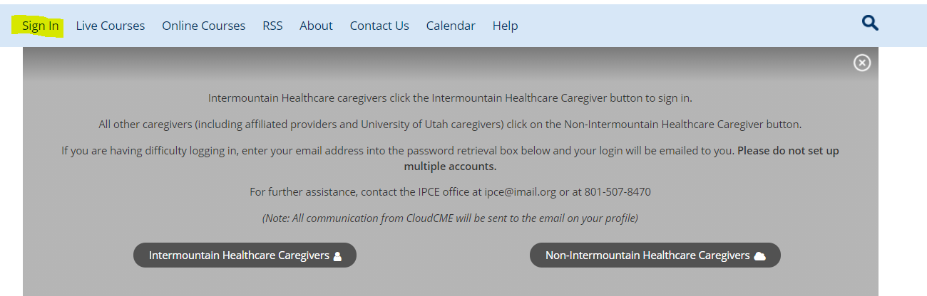
- In Homepage scroll all the way to the bottom and Click on “Administration” next to the white box.
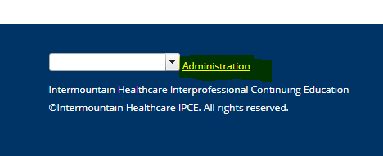
- Click on Activities -> go to RSS Dashboard
- RSS Dashboard tabs
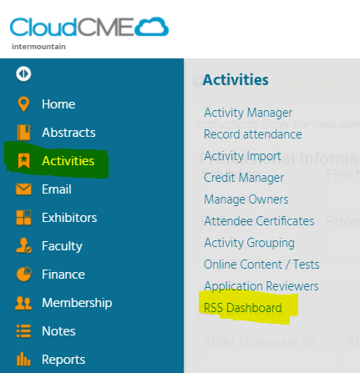
  - The RSS dashboard defaults to the current month and to “Incomplete” for the status, so check your date range and change the “Status” to “All”
  - Review each status an activity session can be in:
    - Incomplete – the COI is not signed for a speaker or there isn’t a speaker added
    - Pending – the activity is waiting approval, the disclosures are signed waiting for flyer to be proofed.
    - Approved – the activity is complete and can get credit
    - In Review – there is a Conflict of Interest that needs to be resolved
    - Rejected – a conflict of interest cannot be resolved and therefore the session is not eligible for credit
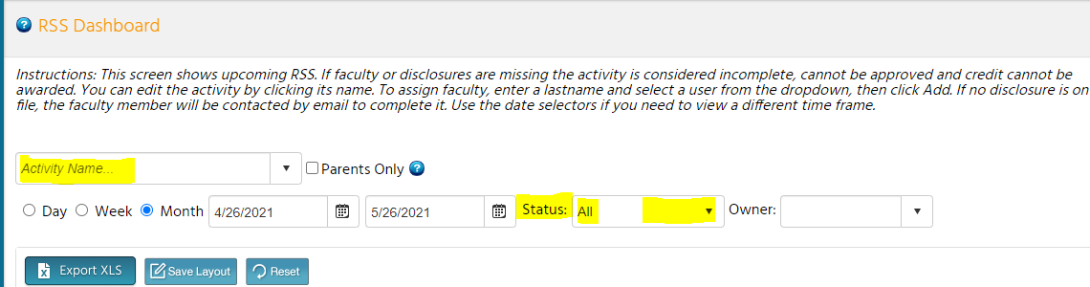

  - Activity ID – Tab Parent and Child
    - Parent ID is the main series identification this never changes
    - Child ID is the number given out in each session to claim credit, each session has a different unique number.
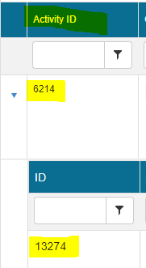

  - Topic Tab – Changing Date, Title, Objectives, Deleting

    - Changing date – can be done through Activity Editor or through Calendar
      - Activity Editor
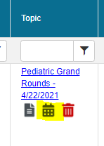
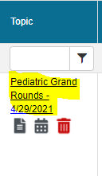
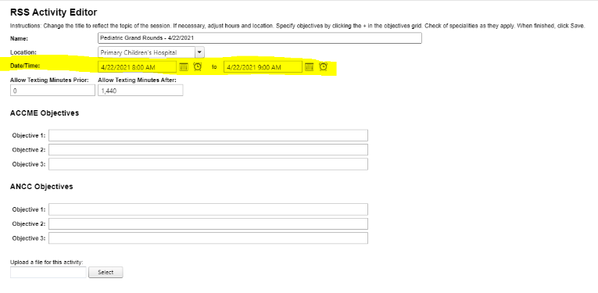

      - Calendar

Changes can be made in the calendar by double clicking on the activity date. Once clicked on you can change the name of the activity, the date and time. You will want to click on “Edit only this Occurrence.” Then click on “options” to get you to the page to change the name and or time.
You can also drag the activity to a different date, it will automatically change the date in the flyer and on the main page. You can also double click on an empty date to add an activity, and follow the same steps as editing a pre-existing activity.
When adding a new session via the calendar, make sure to go in and double check the objectives and were added to the child activity.

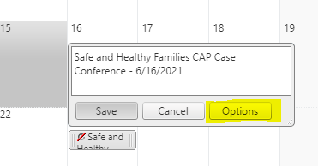
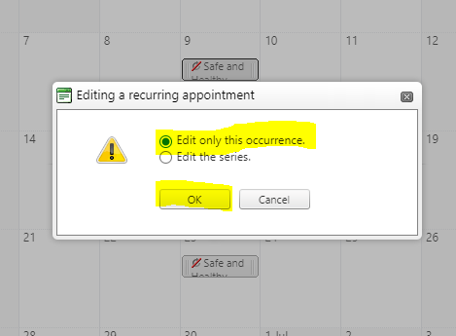
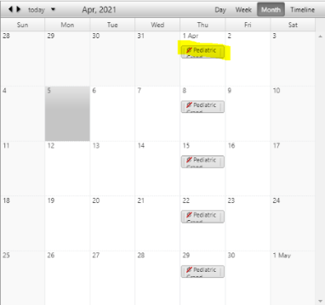

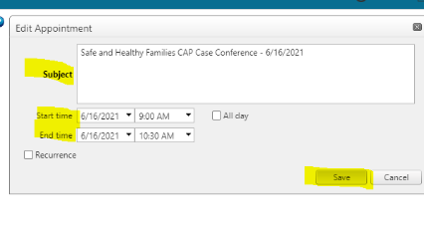

    - Changing Title – You can adjust the title of each session by editing the name
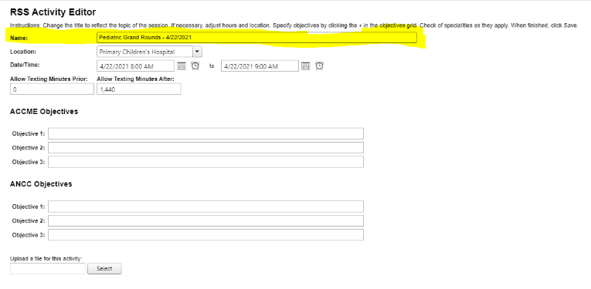

    - Changing Objectives – If speakers have their own objectives for the session, add them here so they can populate on the flyer. Otherwise the flyer will autofill with the RSS’ universal objectives submitted with the application.
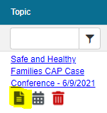
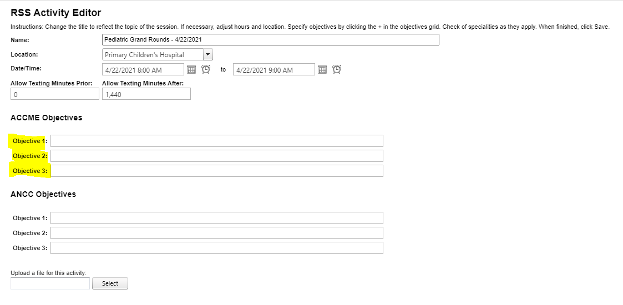
  - Flyers – Pulling Word document – Only pull flyer when activity is approved (review steps below)
    - Under Topic Tab –
      - Click on Paper looking sign
      - Download flyer to distribute. Make sure all credentials and names (full professional) are correct.

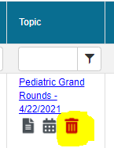
  - Deleting Activity – can be done with trash can symbol or through calendar symbol.
It will ask for a reason you’re to deleting in the comment section.

  - Faculty Tab – Adding Faculty 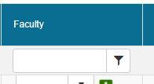
    - Click on “Add New Faculty Member”
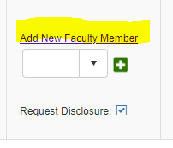
    - Search using last name – if they aren’t in the system see # 5
      - If they are in Cloud system -> Click Add Faculty
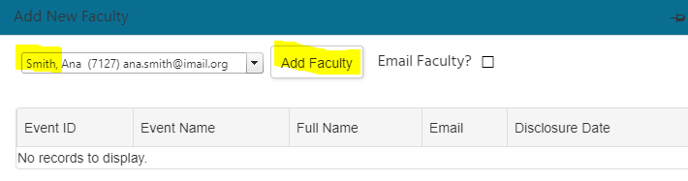
    - If deleting a Faculty click the red minus sign
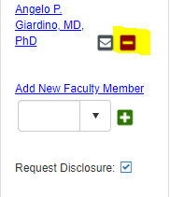
  - Disclosure and other assigned speaker forms – where to find them
    - After faculty is added they will be prompted to fill out a disclosure form along with the other forms for the activity. Faculty should be added four weeks before the presentation date.
      - Disclosure (Required) - New faculty are required to fill out the disclosure. Once completed it will be good for 1 year. This form is for any financial conflicts of interests
      - Speaker Recording (optional) – This form is optional and is only required if the series or session is recorded
      - Faculty Bio (optional) – the speaker can upload their bio for the introduction
      - Presentation Uploads (optional) – this one can be selected if the speaker needs to upload their presentation
    - All assigned forms are found on the CloudCME main page under “My Tasks” all tasks assigned to the speaker will be here.
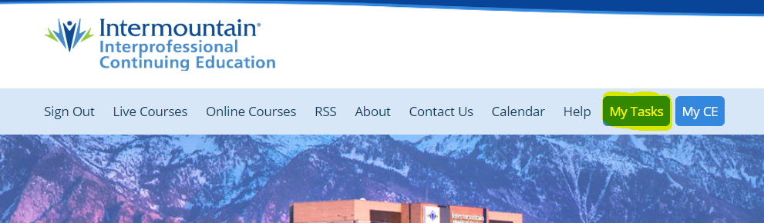
  - Claiming Credit
    - To claim credit for a session each session’s code is the Child ID for that session.
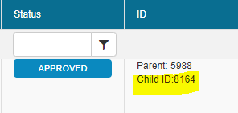

  - Pulling Reports – Under the Left Column click reports
    - Transcripts – this is where you can find the physicians transcripts of activities they’ve attended.
    - Credits – you can view credit hours by a certain activity date or date range
    - Credit Summary – you can see who claimed credit for each session
    - RSS Attendance History – View how many people have attended the session over a period of time

- Adding Speakers not in the System – using the Membership tab
    - Create a profile for the speaker – this is can easier depending on your speaker, on occasion a speaker will not create a profile, or they are taking too long. In this case you can create a profile for them so they can be added a faculty for a session. We try to avoid doing this whenever possible especially with internal employees, it causes a single sign on issue within CloudCME.
        - You will click the “Membership” in the left column -> go to Add Member -> fill out information for speaker all red stared sections.
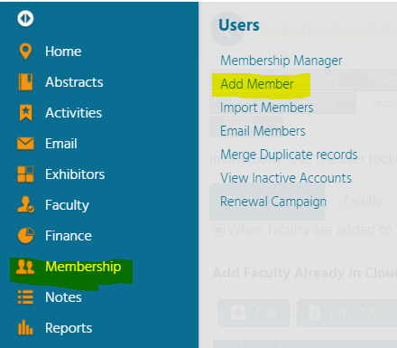
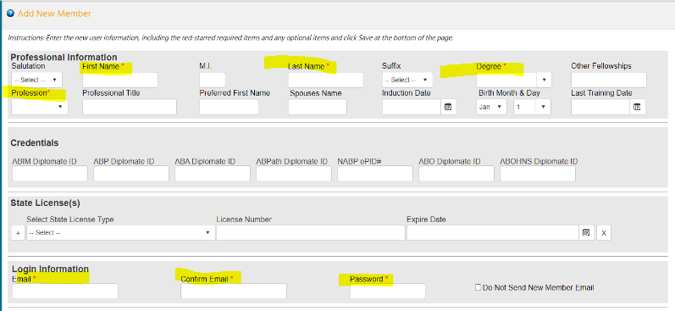

        - You will then need to create a temporary password for the speaker and send them an email stating that you’ve created profile and they will need to log in using the temporary password (TempCME1). Make sure to mention they will need to complete their profile when they first log in and can change the password in the profile tab.
    - Then add the speaker as faculty to the series. This can be done before they complete their profile since they are in system.

Standardized Tasks for RSS Coordinators
- Speakers need to be added into Cloud at least 3 weeks before presentation date.
  - IPCE understands that changes can happen and can accommodate if they occur.
- Disclosures and COIs need to be submitted at a minimum of 1 week before the presentation date.
  - COIs take multiple days to resolve.
  - If a COI is received with less than 3 business days before the presentation date it cannot always be resolved and therefore credit cannot be given for that series session.
- RSS Coordinators need to pull the flyer from CloudCME to send out to group. The goal is to have them approved two weeks before session date.
  - RSS coordinator will get the flyer from CloudCME
  - The flyer can be pulled for distribution only AFTER the session has been approved in CloudCME.
  - The CloudCME auto generated flyer is not required to use, you can create your own, all flyers are required to be sent out with certain verbiage in it… i.e accreditation statements and showing disclosure for speakers and planning committee members.
  - If using a non-CloudCME flyer, send it to the IPCE coordinator to send through the proofing process just like with all flyers. Once approved, it will be uploaded to CloudCME and approved.
  - A non-CloudCME flyer needs to be uploaded to CloudCME to be proofed at least 3 weeks before the session.
  - The sooner the speakers are added the sooner the flyer will be approved and can be distributed.
- If any changes happen from time of approval, to time of the session the RSS coordinator should reach out to the IPCE coordinator to explain what has happened.
- Include IPCE coordinator to the distribution list for RSS series. Adding the IPCE coordinator to the distribution lists helps IPCE keep track of when sessions are happening. We also like to join in on some sessions when possible.
- After the session is complete give the activity ID to the attendees so they can claim credit for participating in the live activity. Use the PPT slide given by the IPCE coordinator. This slide gives instructions on how to claim credit and the credit code. The credit code changes for each session, so the slide will need to be update.
  - The PPT isn’t mandatory but is recommended for the first few sessions until all participants are familiar with the credit process.

Standardized Tasks for IPCE Coordinators
- Speaker must submit their disclosure forms at least one week before the sessions date
- If there is a financial conflict of interest, there are more steps to be taken. We need more information to start the resolution process.
  - Include all the information needed along with PDF of the COI
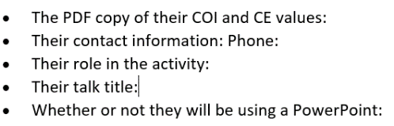
  - Include PPT presentation as soon as it’s received (this can happen after the COI is submitted since the speaker doesn’t always have it complete when assigned as faculty)
  - Upload the PPT into CloudCME to finish the rsolution process
- As soon as the speaker is added into the system, IPCE Coordinator will send the flyer through the proofing process. At least 3 weeks before session date.
  - The sooner the speaker is added the sooner the flyer will be proofed at a minimum of 3 weeks before.
  - If any changes need to be made by the RSS coordinator or if there is a COI the IPCE coordinator will reach out with information and instructions for the next steps that need to be done.
- After the proofing is complete the RSS activity will be approved no later than 2 weeks before the session.
- Review the claim for credit slide and when to show it during the RSS. Discuss the importance of having attendees claim credit.

